## Intro
You’re anxiously watching the progress bar on your monthly AI budget allocation as your favorite little buddy tries the same command line action for the 5th time. This time he’s gonna get it right you think to yourself.
A little while later you’re scratching your head as the agent you tasked with implementing a simple new endpoint on your application, generates a two page design document describing the 15 steps needed. You let out a sigh and start implementing yourself.
If you’ve been using AI coding agents or assistants in past 6 months, these should sound familiar. And you have either accepted this or like me have been trying desperately to stretch that precious token budget.
In this post I’ll share some insights, tips and some handy tools that’ll make your coding buddy last a little longer.

## Typical issues and tips to fix them
After using agents the past months
Wrong agent model configuration

Runaway loops
Unexpected escalation of scope?

## Tools
### Caveman
Caveman promises to minimize output token spent by forcing less chatty output.
After some use, this promised saving seems to be exaggerated.
On simple question and answer flows, saving was negligible

 | Model | Input | Output
Standard | Sonnet
Caveman default | Sonnet
Caveman Ultra | Sonnet

## Graphify
Small cost to build the graph
Seems to work for code searching

## Ponytail
Forces Yagni principles

BE implementations -> great way to force simpelestr solutions

FE features however are a different story imo
When asking to implement the exact same rating feature, ponytail defaults for standard dropdown, while vanilla-claude implementsa a custom rating component. Yes this is in essence more complex, but it also
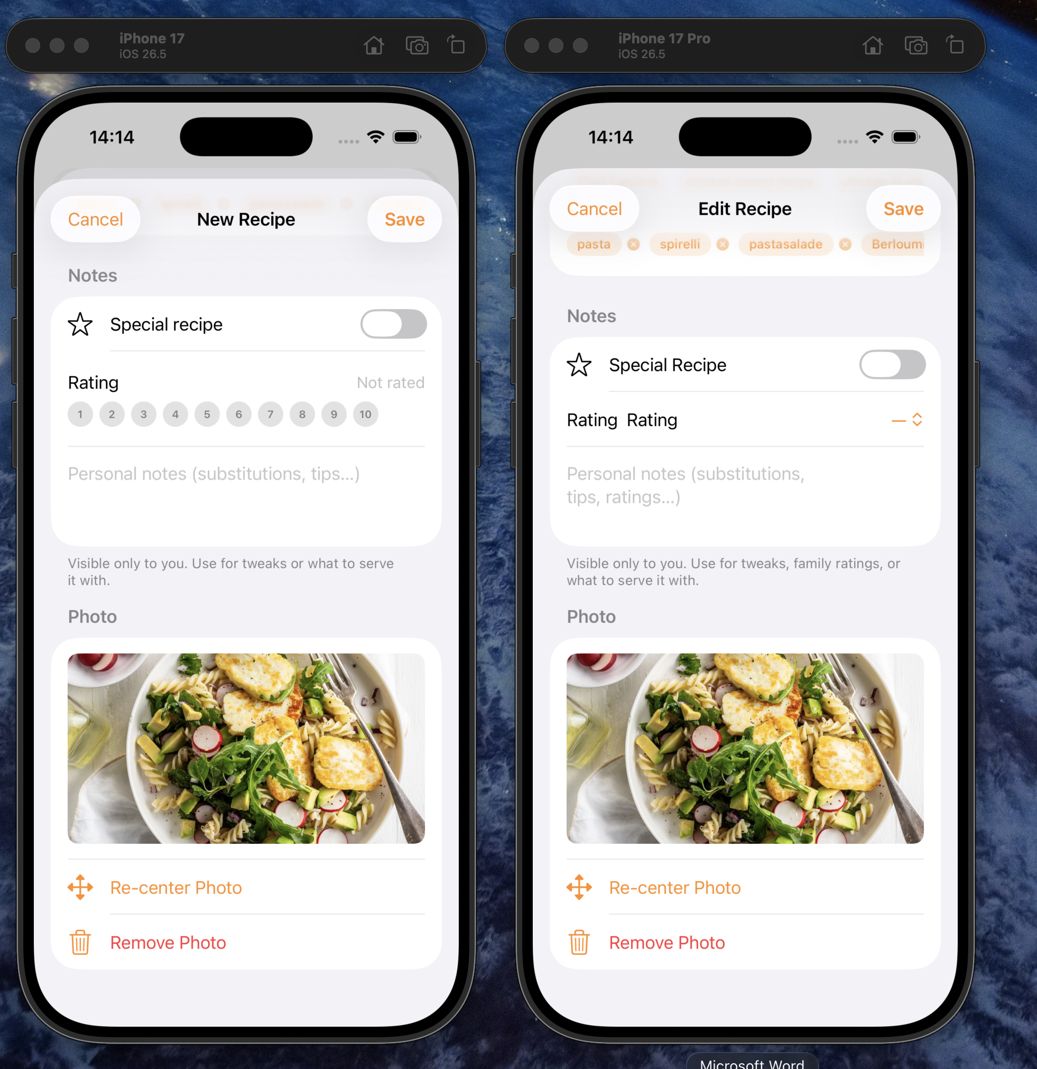

Considering this, ponytail does however result in token savings.

